Year 7: Game Control Unit
Tutorial 3: Adding behaviours
Destroying Actors and Following paths

Learning outcomes covered in this tutorial
Level 3 | Create programs that implement algorithms to achieve given goals. | Declare and assign variables. | Use post-tested loops e.g. 'until', and a sequence of selection statements in programs, including an if, then and else statement
Level 4 | Know the difference between, and appropriately I can use if and if, then and else statements. | Use a variable and relational operators within a loop to govern termination. | Design, write and debug modular programs using procedures. | Know that a procedure can be used to hide the detail with sub-solution (procedural abstraction).
Level 5 | Know that programming bridges the gap between algorithmic solutions and computers. | Use a range of operators and expressions e.g. Boolean, and apply them in the context of program control | Select the appropriate data types

Part 1: Setting up collision groups
Step 1: It is important to set up collision groups so you can set which actor types can collide with which. Click on the settings tab and then groups. Click on the green create new at the top of the window that pops up.
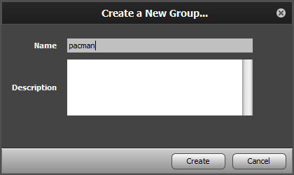
Name the first group pacman. Create another group called ghosts and a final one called food.
Go back into your pacman group and set it to collide with food and ghosts.
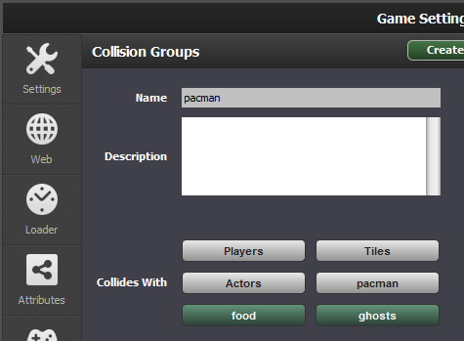
Set the ghost group to collide with pacman.
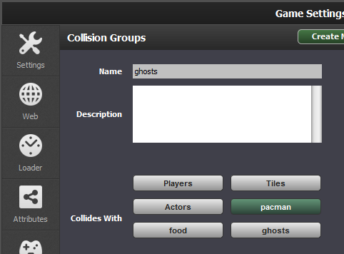
Part 2: Destroying Actors
We are going to create a behaviour that can be used for both eating food and destroying pacman if he is eaten by a ghost.
Step 2: Go to the Actor Behaviours tab and click create new, name the behaviour ‘Destroy Actor’.
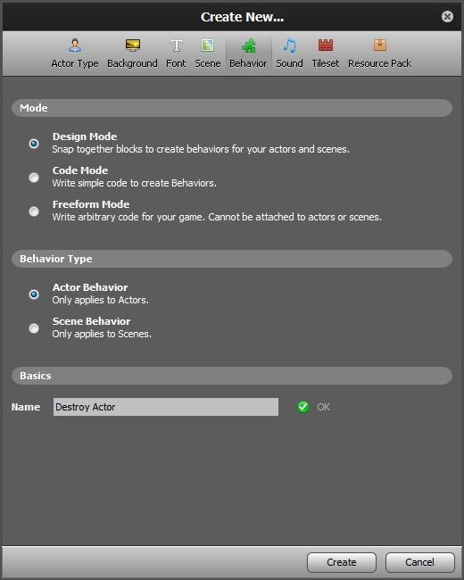
You will now be in Design Mode. Add an Actor of Type Collision Event (click + Add Event button on the left, then select the Event, as shown).
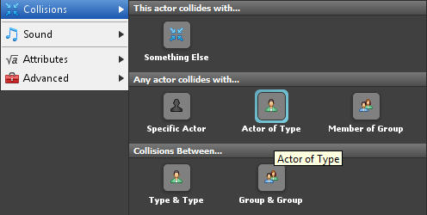
Step 3: We will create an attribute for the actor type that will be destroyed when the actor collides with it.
Click on attributes, click on create attribute. Name the attribute actor type and set it to data type Actor Type.
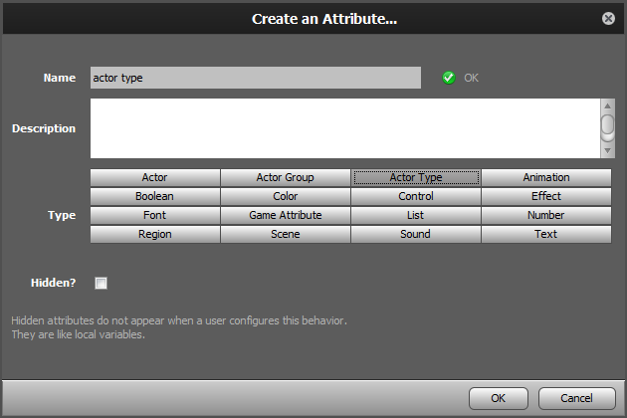
Step 4: Add the actor type attribute to your event as below and then drag over a kill [Self] block from the Palette (under Actor -> Properties).
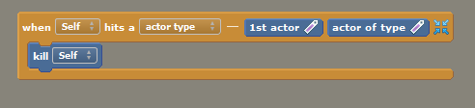
Click on the green attach to actor type
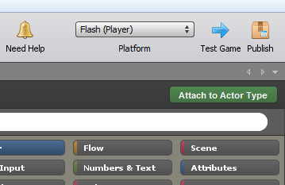
Select food
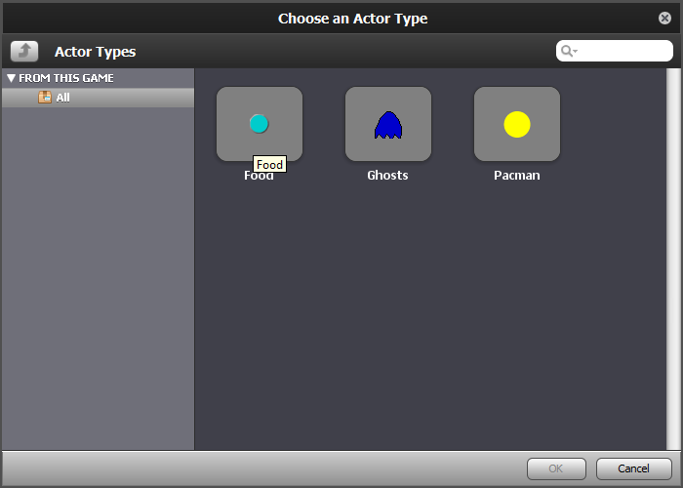
Set the actor type attribute to pacman
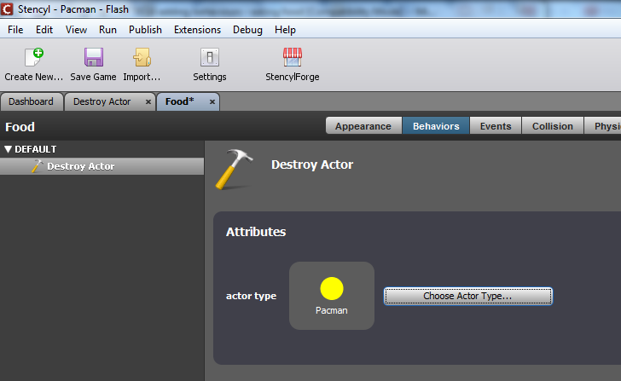
Repeat the steps to add the destroy actor behaviour to your pacman actor type so he is destroyed if he collides with a ghost.
Part 3: Creating a scoring system
Step 4: To start select your pacman actor type, select event and create a new Game Attribute, select Number for its type, and name it score (click the Attributes button on the Palette, then the Create an Attribute button).
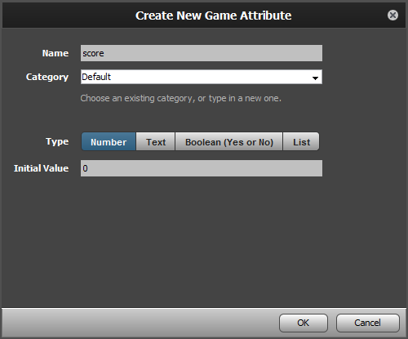
Click OK on the next screen.
Step 5: Now create a When Creating Event (click + Add Event, then mouse over Basics, then click When Creating). After that, click on Game Attributes -> Number Setters in the Palette and drag over the set score to [ ] block, snap it inside the Event, and type 0 into the empty field.
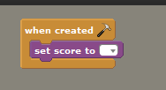
Step 6: Next, add a collision of type block and set the Collision Group to food in the Collision Event and then drag over set score to block (in the Attributes > Number Setters category) and snap it into the Event block. Add a + block from the Numbers & Text category and set it to increment by 1 each time a piece of food is eaten.
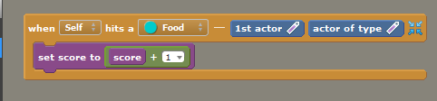
Part 4: Creating a Font
Step 7: Before we can show any text on screen when the player wins the game, we need to create a default Font to use. Click on the Dashboard, then on Fonts, and click the dotted line box to create a new font. Name it Default Font. Change the settings to those shown in the following image (size 32, white for the color, Sans Serif for the font, a style of Normal, Yes for Smoothing) and save your work.
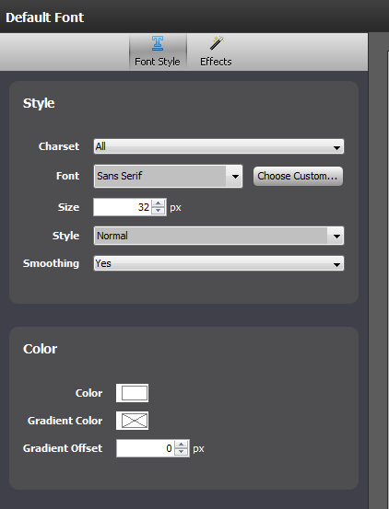
Now we need to create a scene behaviour that will display the players current score on screen as the game is played.
Part 5: Displaying the score
Step 8: Add a new scene behaviour, name it display score
Add a when drawing block and from the Drawing category in the palette at a set current font block (set it to the Default Font you just created) and a draw text block (you will need to play around with the X and Y values to get the score in the right place). Drag in your game attribute score.
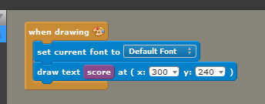
Don’t forget to attach your score to your scene by clicking on the attach to scene button and selecting level 1
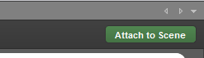

Part 6: Adding a path for Ghosts to move on
In this last section you will use a premade behaviour. Click on your ghost actor, click on behaviours and click on the dotted box to select a behaviour.
Step 9: From the section called from your library select motion and then follow path.
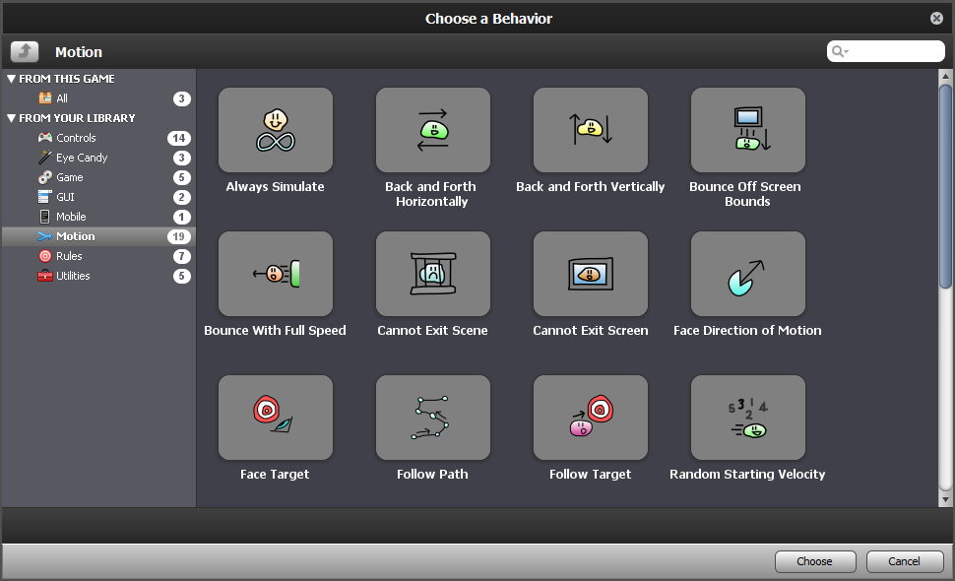

Step 10: You now will need to add the coordinates for each point of your path, click on the + symbol.
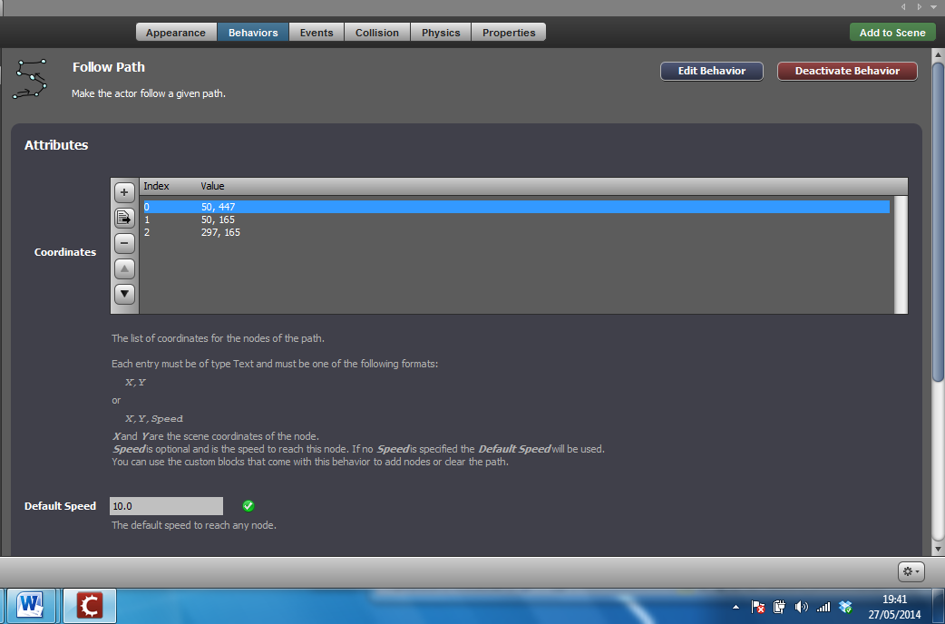
Add the X and Y values (you can check what these will be in the scene, look in the bottom right hand corner as you move your mouse).
NOTE: the data type for this is text
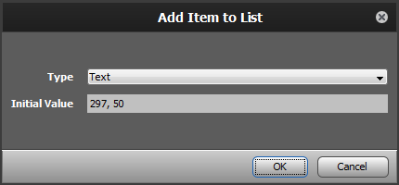
Add as many points as you need – the path will loopso your ghost will keep moving, you will need to create separate ghost actors if you want them on different paths.
Part 7: Final Touches
Step 11: Now that you’ve tested your game and everything works, it’s time to export it to your desktop as a SWF file. That way, you can open the file in any browser to play the game! Click the Publish button in the upper left of the screen.
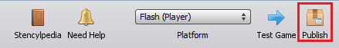
Step 12: Select Flash for the publishing option. This will create a SWF file and ask you to choose where to save the file.
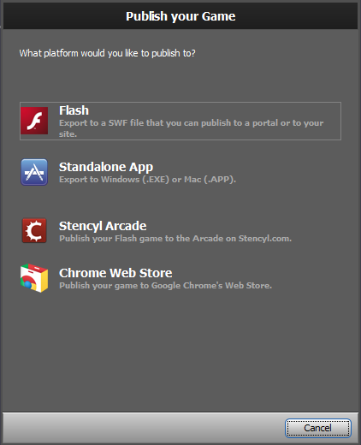
Step 13: Now that you have your Pacman game, you can take on the Challenges that follow, and modify the Pacman game further, or you can start on your own game! The choice is yours.
Here are a few challenges you could take on if you want to take this project further. We won't provide you with any solutions, it's up to you to figure out how to add these features.

Challenges
Challenge 1: Make the game stop if pacman is eaten by a ghost
Challenge 2: Make the game switch to a new level once all of the food has been eaten on level one.
Challenge 3: Make a special state where pacman can eat the ghosts for a special score

Where do I go from here?
There's a whole lot more to Stencyl, and we encourage you to experiment on your own and read through the rest of Stencylpedia to find out how to import your own resources, create your own Behaviors, and enable Stencyl to help you create the games of your dreams.

Visit www.stencyl.com

